**Using time intelligence to compare to previous year**

**Overview**

In the exercise *Using time intelligence to compare to previous year,* you were asked to create and format two measures using time intelligence DAX functions to help Adventure Works compare its sales.

Your tasks in this exercise were to:

* Download and connect to a dataset and review the model.
* Create two measures using DAX expressions.
* Create a matrix in Power BI to view the results of the measures.

This reading provides you with a step-by-step guide for completing these tasks. It also includes screenshots that you can compare against your work.

You can also review *Creating quick measures and creating custom measures with DAX*.

**Step 1: Download and connect to the Adventure Works dataset.**

1. Download and save the Excel workbook **Adventure Works Date.pbix** from the exercise page on the Coursera platform.

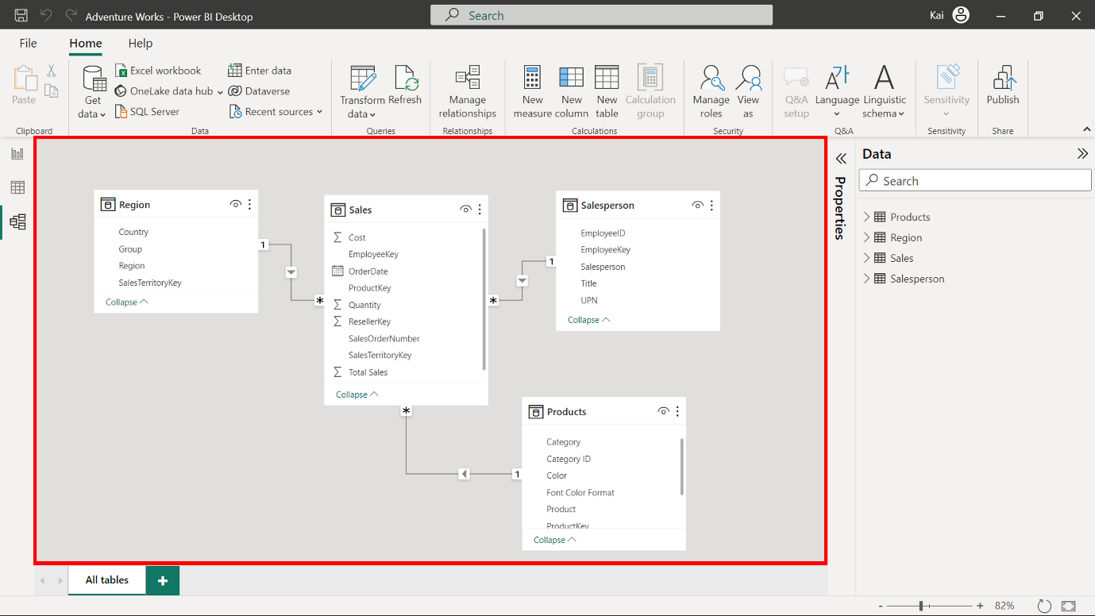

1. Load the data from the Excel Workbook in Power BI.
2. Select the Preview pane to open a preview of the table.

**Step 2: Create the Revenue measure.**

1. To create the revenue measure within your data model, you need to use the **Total Sales** column from the **Sales** table and the **Quantity** column from the **Sales** table as follows:

1

Revenue = SUMX ( Sales, Sales[Unit Price] * Sales[Quantity])

* In this measure, the **SUMX** function computes the **Total sales** by multiplying the **Unit price** by the **Quantity** column of the **Sales** table.

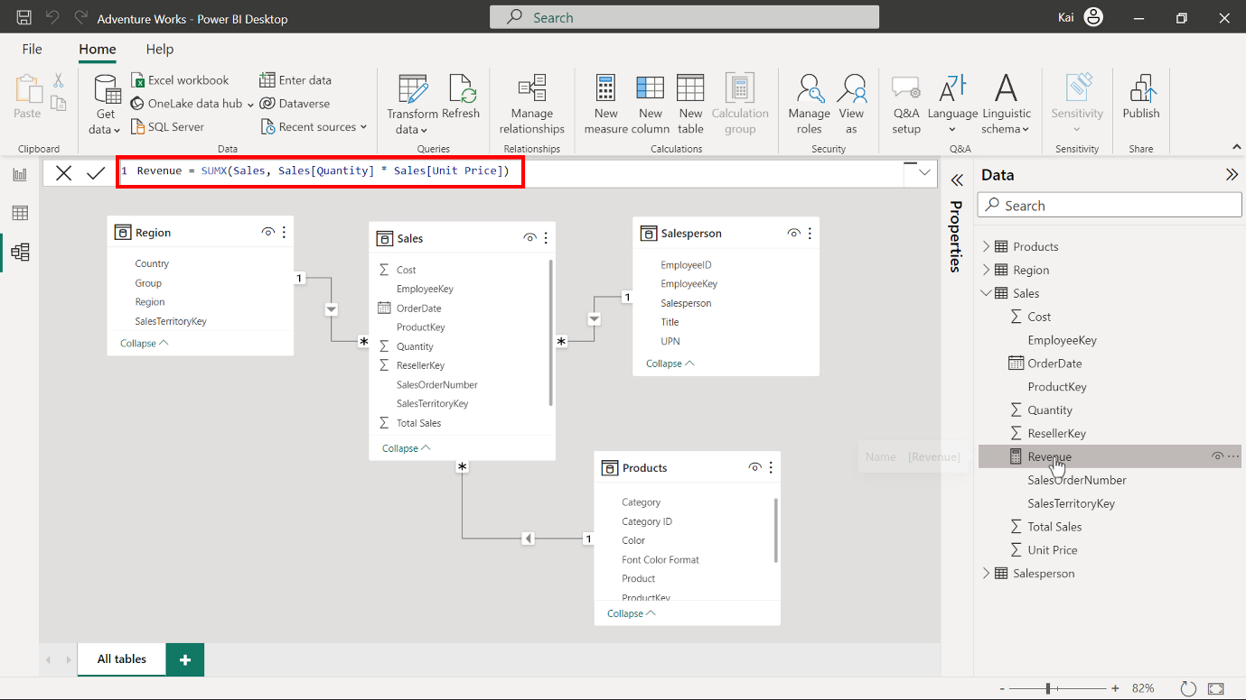

1. To format the measure, select the newly created measure from the **Data** pane. Then navigate to the **Format** group in the **Measure tools** tab of Power BI. Select **Currency** from the **Format** drop-down menu.

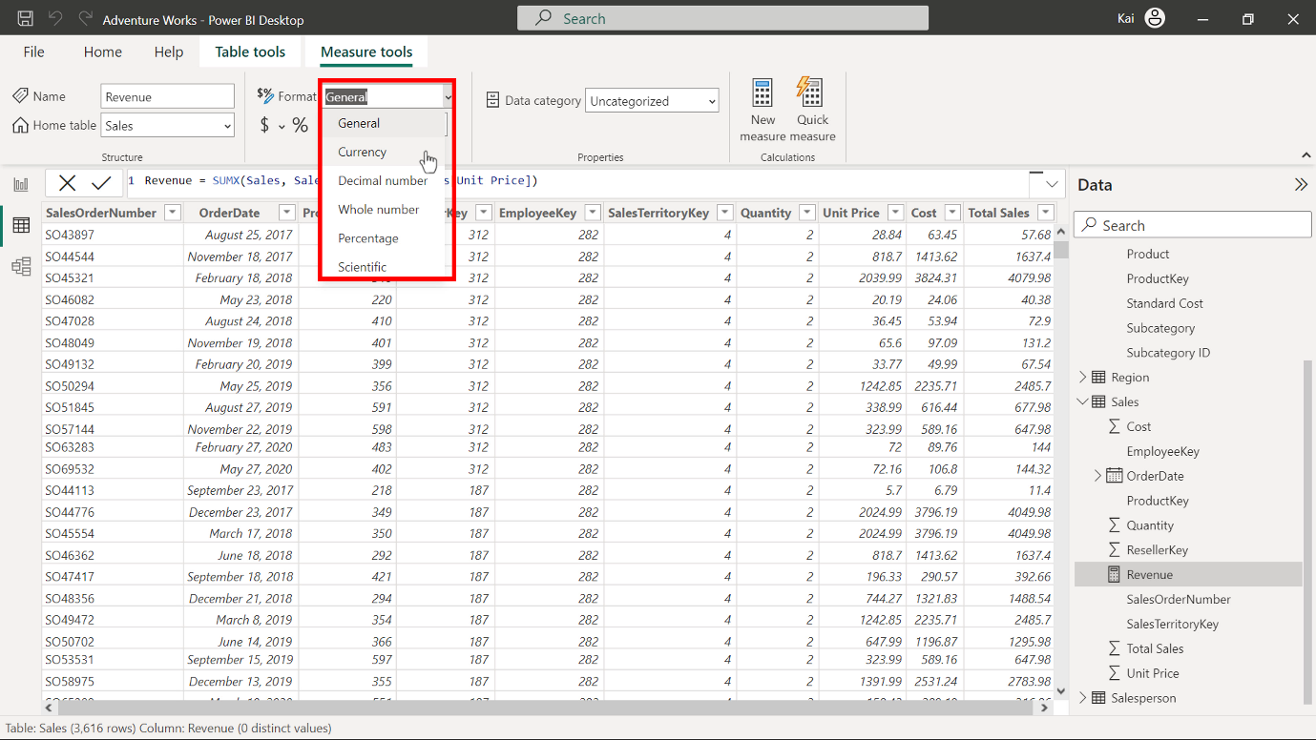

Enter **2** in the decimal places (currently **Auto** by default). This action formats the measure as a **currency** data type within two decimal places. This is best practice for visualization purposes.

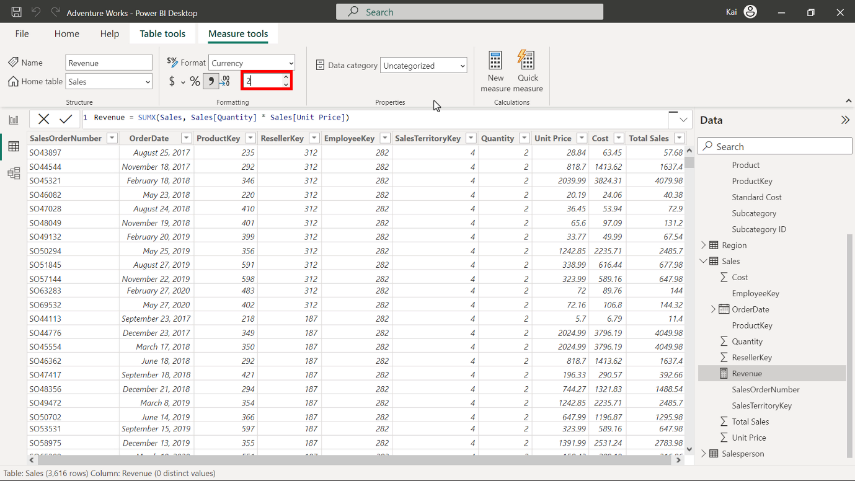

**Step 3: Create the previous year’s and year-over-year revenue changes using DAX query.**

1. To create a new measure named **RevenuePY**, access the **Data** view. Under the **Date** pane, select the **Sales** table. Then select **New measure** from the **Calculations** group to expand the DAX formula bar. Add the following DAX expression to compute the **RevenuePY** measure.

Revenue PY =

VAR RevenuePreviousYear =

    CALCULATE ([Revenue], SAMEPERIODLASTYEAR (Sales[OrderDate].[Date]))

RETURN

RevenuePreviousYear

* **VAR** is the variable defined for the previous year’s revenue.
* **CALCULATE** computes the total revenue using the **SAMEPERIODLASTYEAR** function, which uses the **Date** column from the **Sales** table as a parameter.
* **Revenue** in the square brackets is the previous measure you created.
* **RETURN** displays the value of the entire expression.

Once you execute the code, the **Revenue PY** measure appears in the **Data** pane under the **Sales** table.

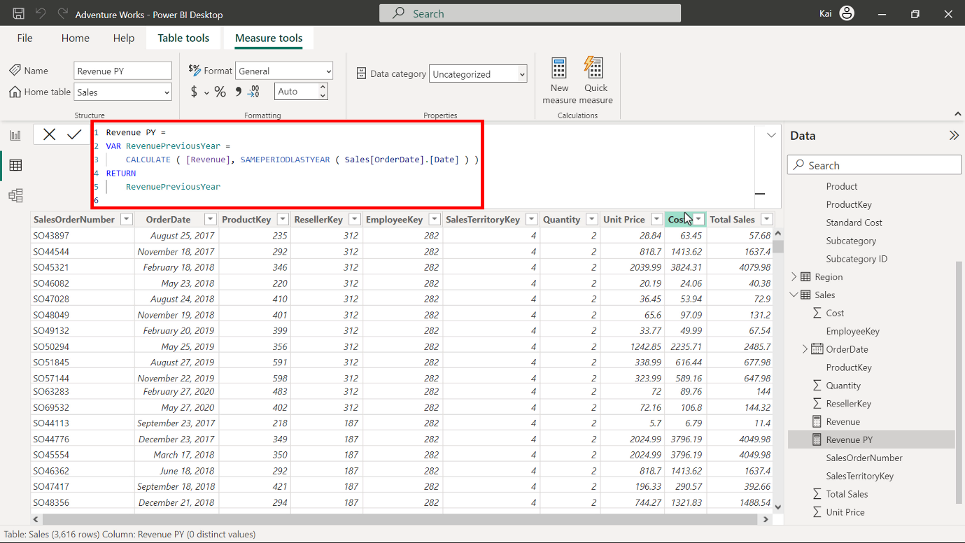

1. To format the new measure, select it from the data pane. Then navigate to the **Formatting** group in the **Measure tools** tab of Power BI. Select **currency** data type from the **Format** drop-down menu. Enter a value of **2** in the decimal place field (currently **Auto** by default). This action formats the measure as **Currency** data type within two decimal places and is good for visualization. You can view the results of the measure in the following diagram.

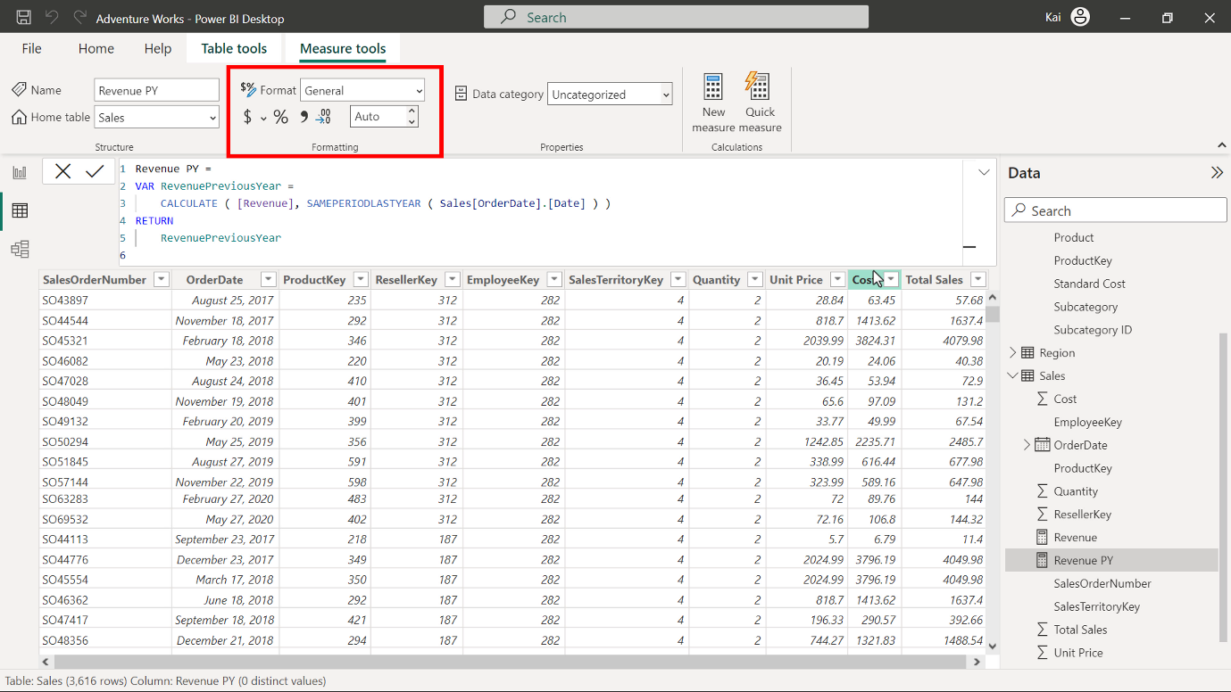

1. Repeat this process to create a new measure named **Revenue YoY %** using the following DAX code:

Revenue YoY % =

VAR RevenuePreviousYear =

    CALCULATE ([Revenue], SAMEPERIODLASTYEAR (Sales[OrderDate].[Date]))

RETURN

    DIVIDE ([Revenue] - RevenuePreviousYear, RevenuePreviousYear)

* In the above expression, in addition to the previous calculation, the **DIVIDE** function computes the change ratio of **Sales** by dividing the difference of the current year’s revenue by the previous year's revenue.

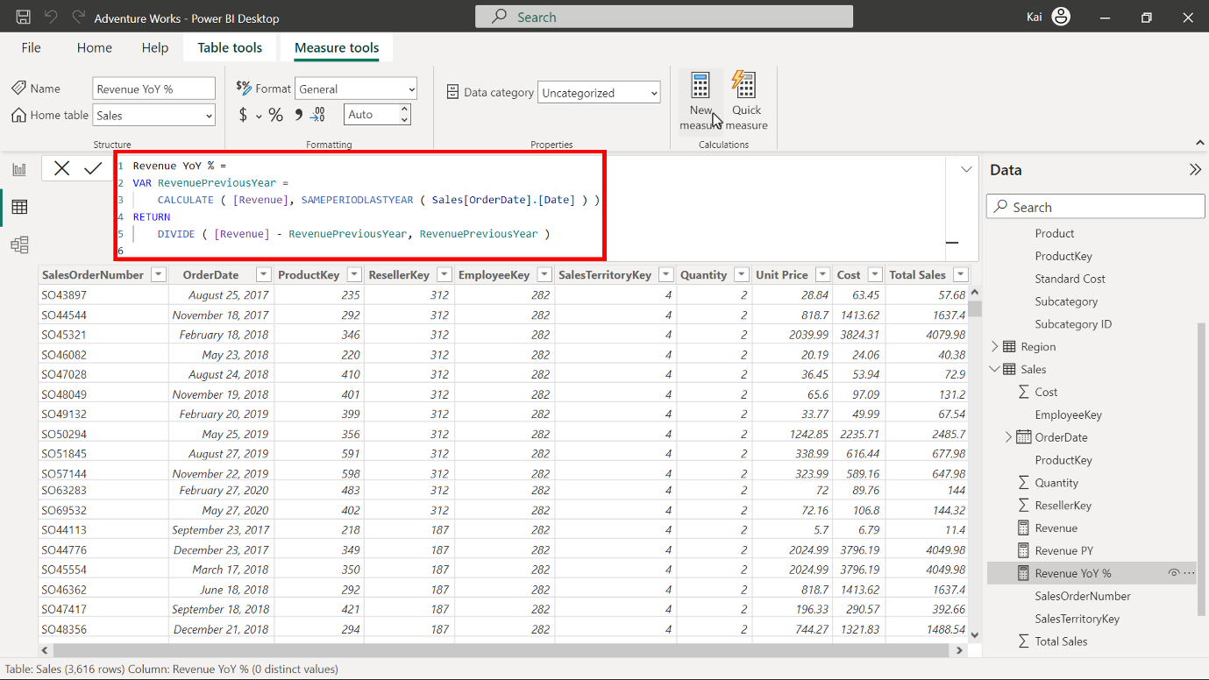

1. Repeat the formatting process from step 2. In this instance, remember to select **Percentage** instead of **Currency**.

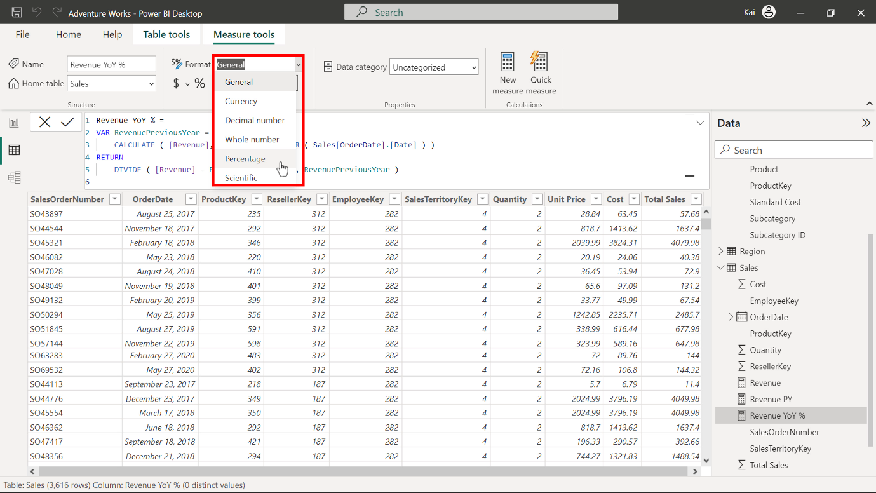

Enter a value of **2** in the **decimal place** field.

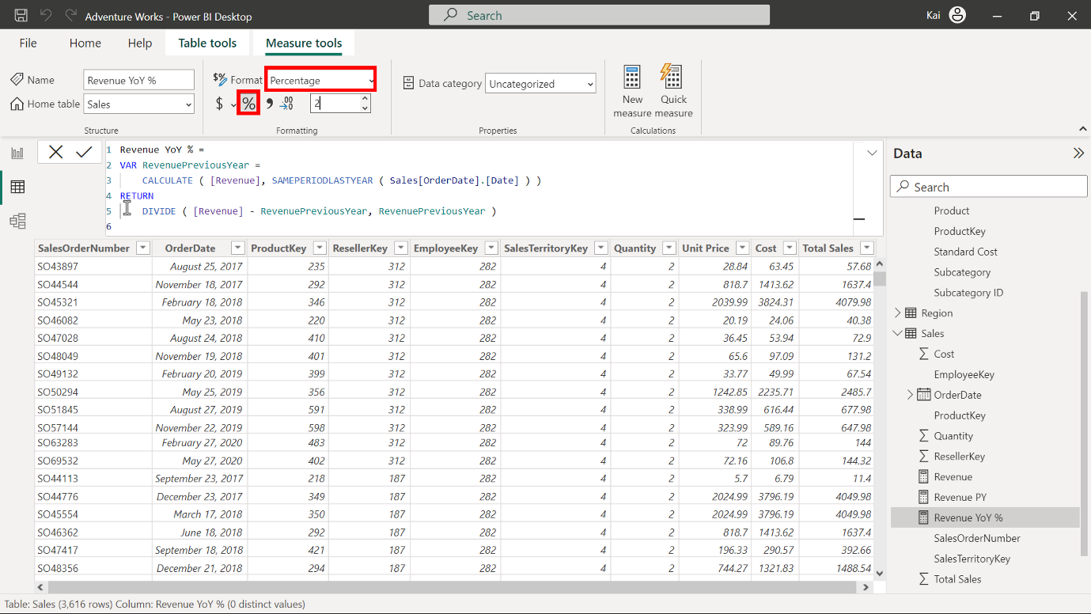

**Step 4: Update the matrix in Power BI report view with the measure results.**

1. Navigate to the **Report view** of Power BI desktop.

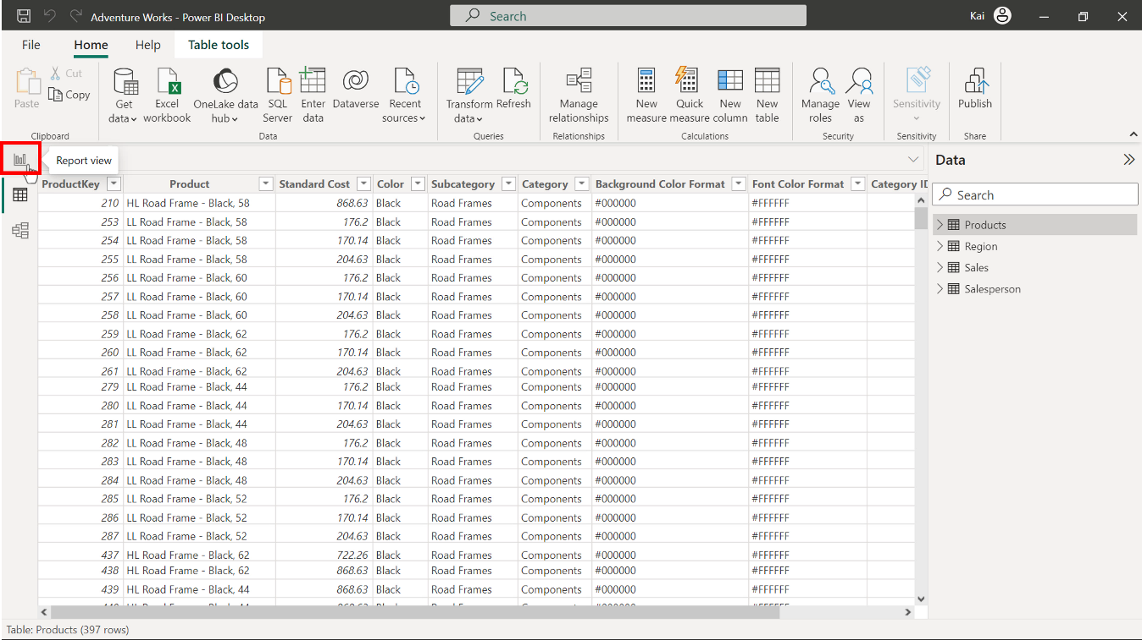

A premade matrix is present with a **Year** and **Month** column.

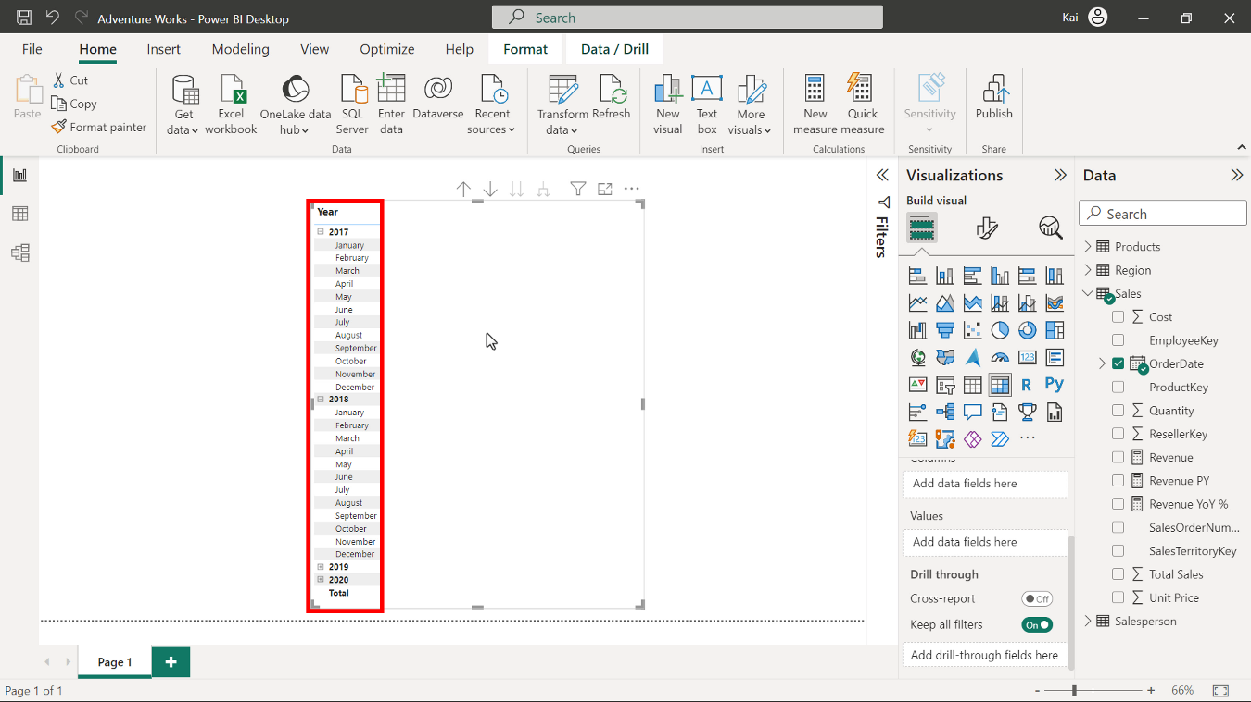

Bring the **Revenue**, **Revenue PY** and **Revenue YoY %** measures you have created to the matrix under the **Values** section.

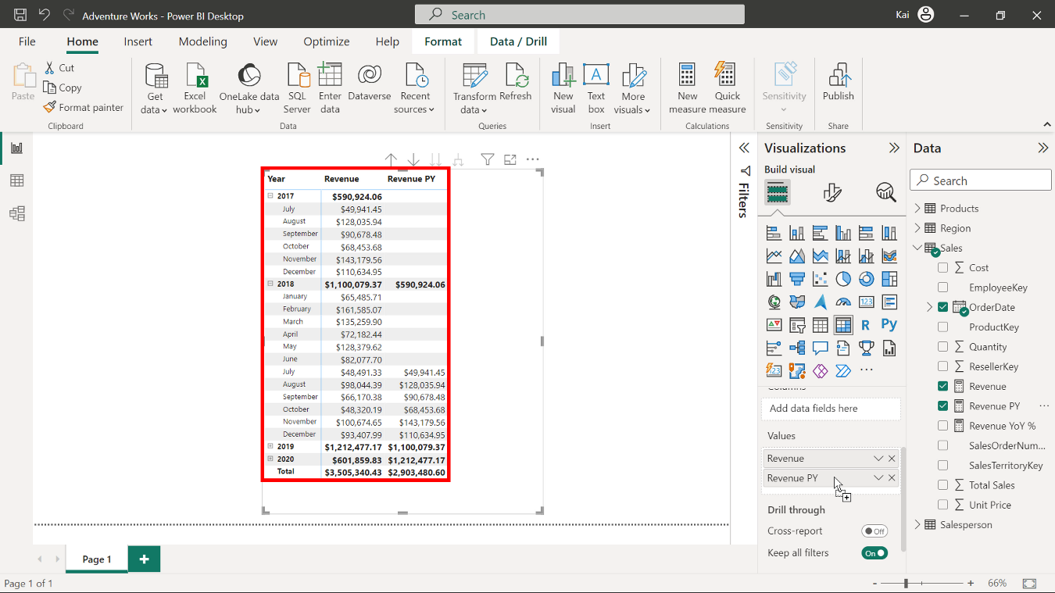

1. Note the values in all columns of the matrix. You can expand the **Year** by selecting the **plus** sign on the left side of the Year **column** in the matrix. A matrix view of the measure’s results is visible in the diagram below.

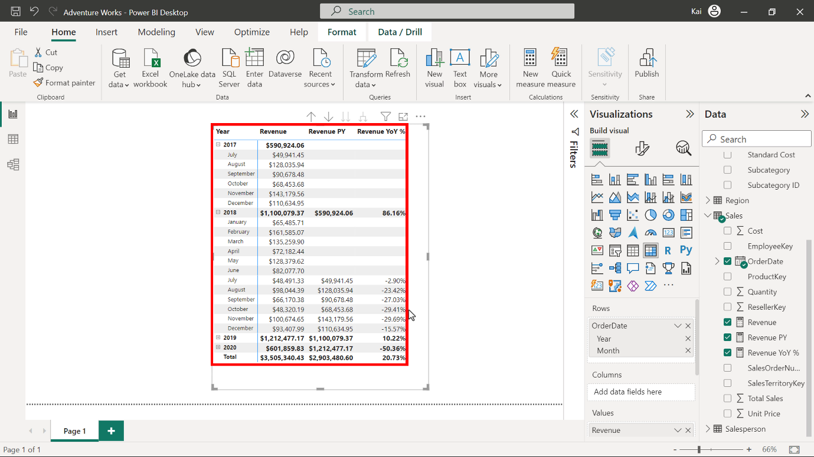

**Step 5: Save the Power BI project.**